**POSTGRESQL INSTALLATION IN UBUNTU XENIAL**

REF:

<https://help.ubuntu.com/community/PostgreSQL>

<https://www.digitalocean.com/community/tutorials/how-to-use-postgresql-with-your-django-application-on-ubuntu-14-04>

<https://help.ubuntu.com/community/PostgreSQL>

1. GET UPDATE:

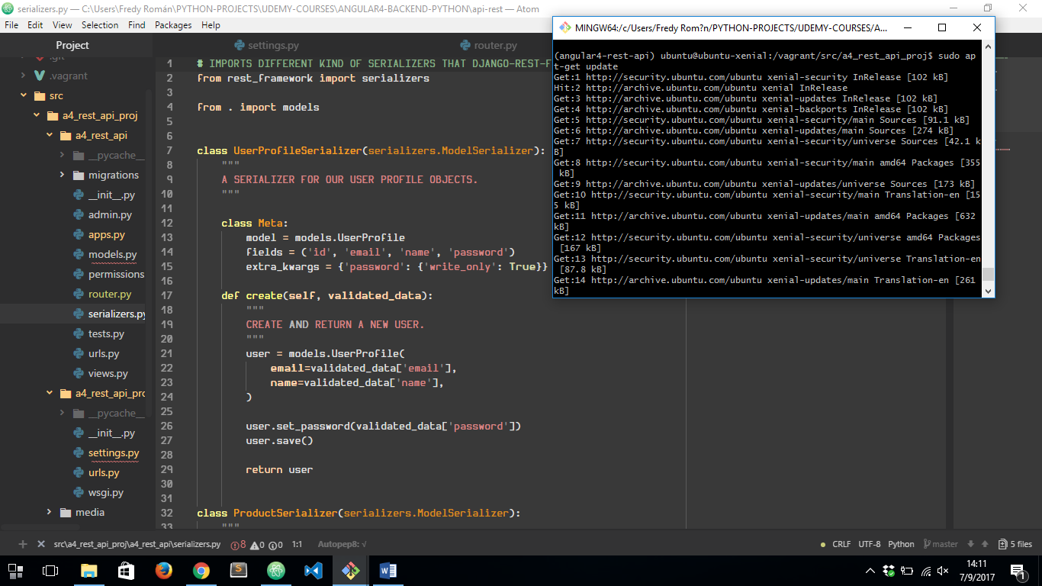

1. INSTALL POSTGRESQL AND POSTGRESQL-CONTRIB:

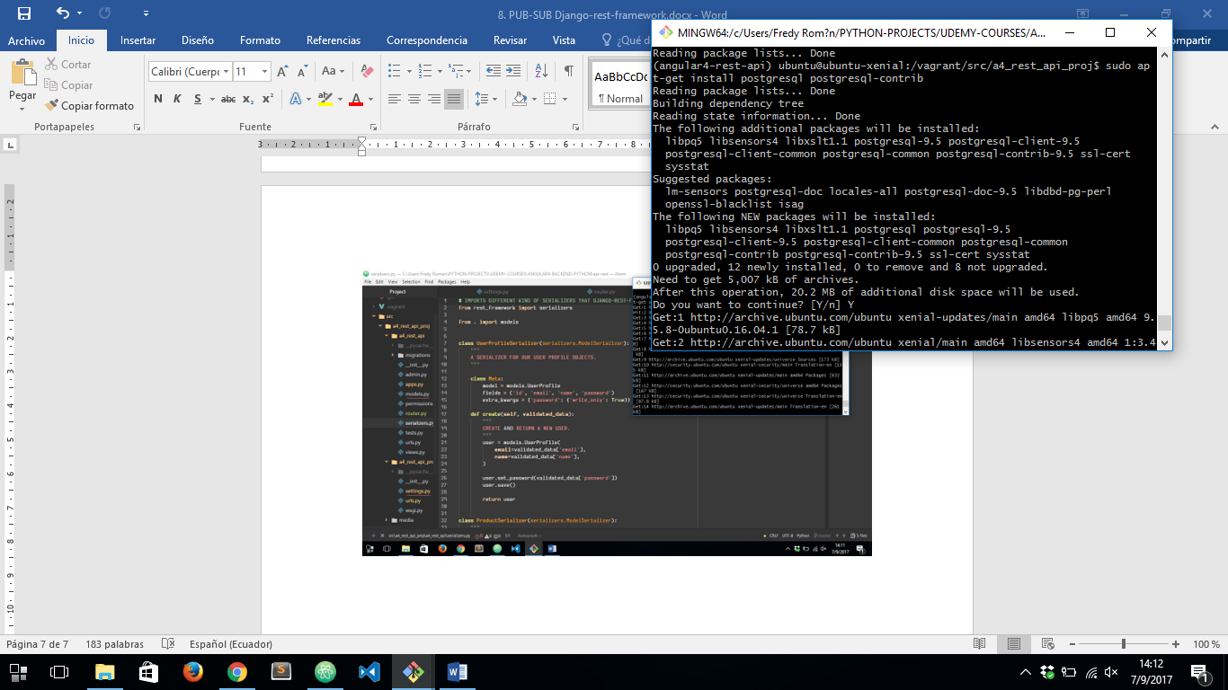

FINNALY WE WILL HAVE OUR POSTGRESQL INSTALLED:

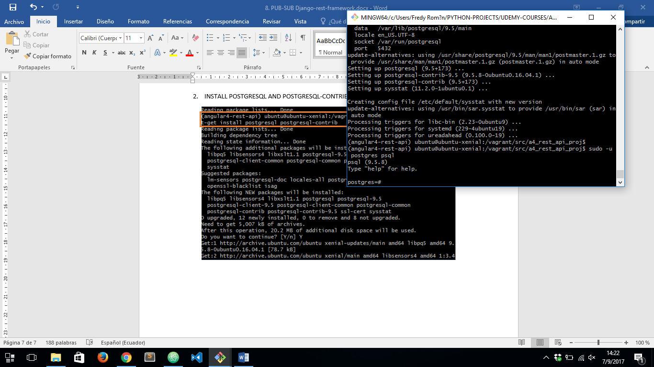

RUNNING COMMAND: ***sudo –u postgresql psql*** TO OPEN POSTGRESQL’S COMMAND LINE WITH DEFAULT DATABASE ***postgres***

NOW WE ARE ABLE TO CONNECT OUR DJANGO APP TO POSTGRESQL

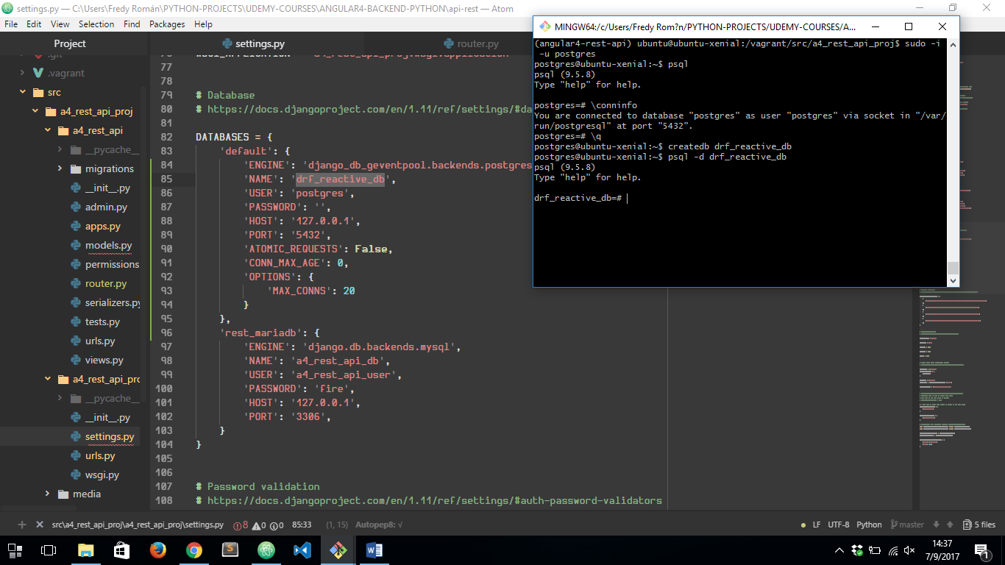

NOW WE HAVE TO CHANGE ***postgres*** USER PASSWORD AND THEN SPECIFY IN ***settings.py***

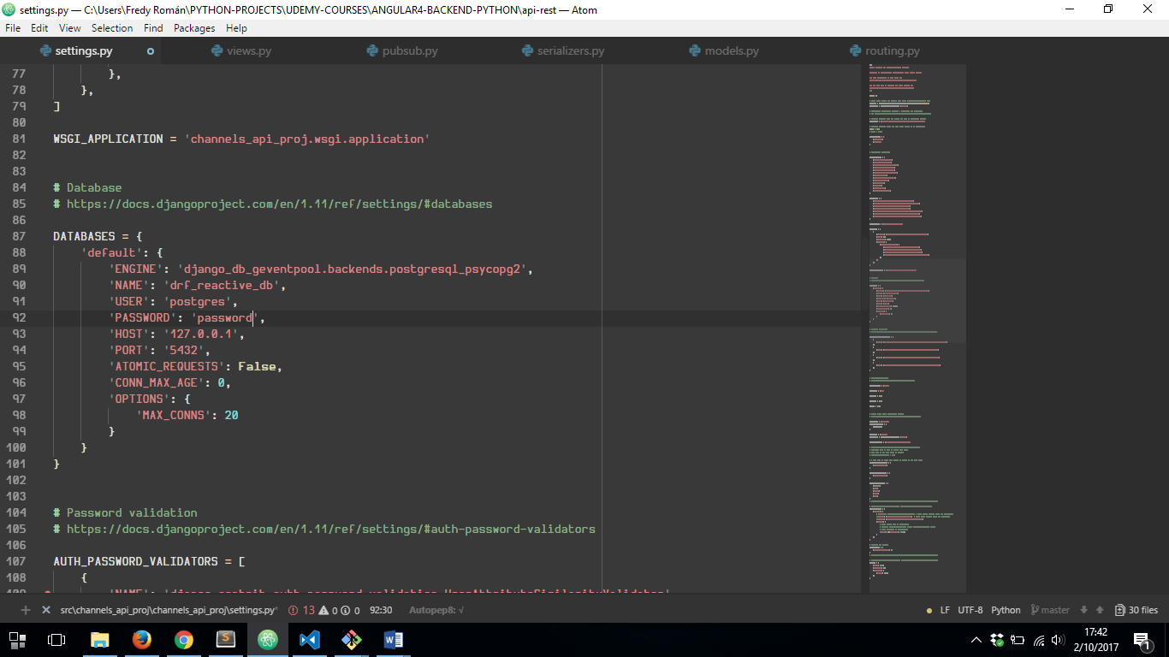

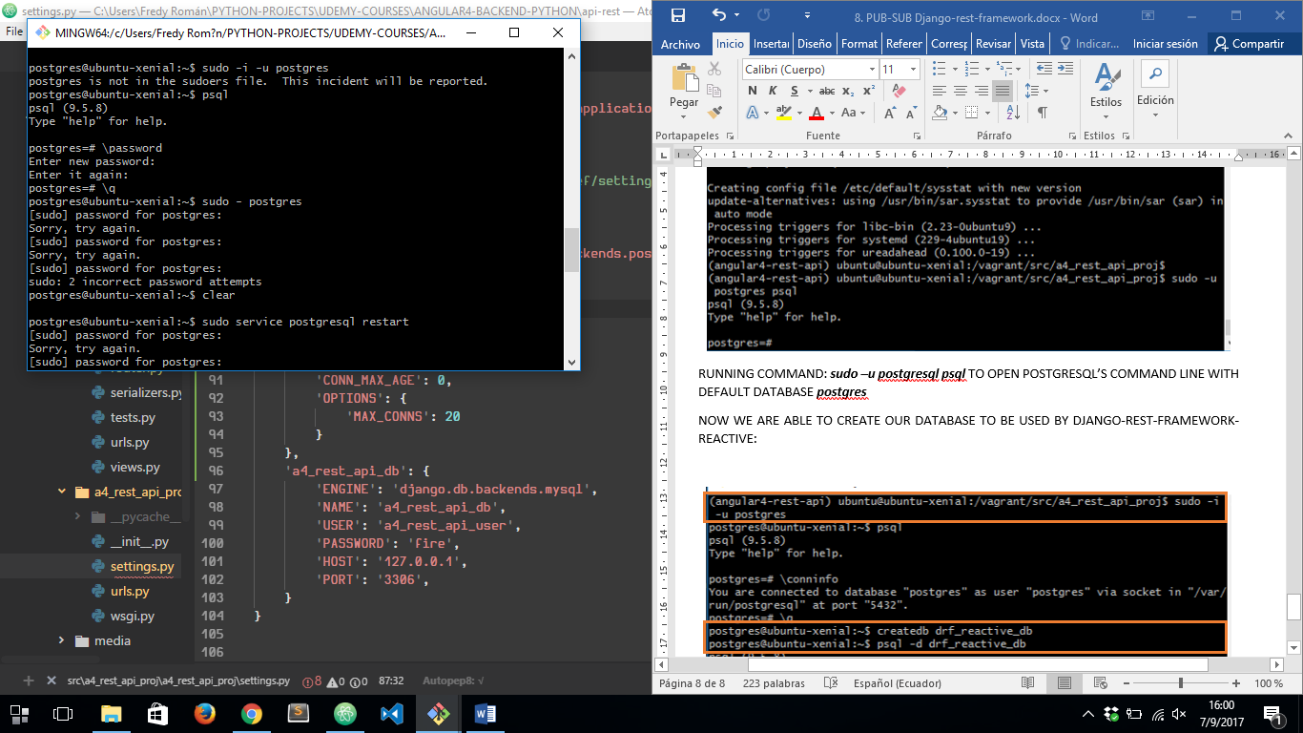

THEN WE HAVE TO RESTART POSTGRESQL SERVICE TO MAKE CHANGES OCCUR:

